Module title
Module 7 Decarbonised Heating & Cooling Project Delivery & Coordination
Led by CVUT and Energie Cities
Overall aim
This module enables learners to coordinate and support clean heat projects by applying practical project integration and collaboration methods. Learners will be able to manage dependencies, information flow and change requests, use digital collaboration tools effectively, and communicate clearly with stakeholders. They will produce coordination outputs (e.g., tracker updates, issue/risk logs and stakeholder notes) to support timely, high-quality delivery.
Module length
2 hours in online self directed learning.
Module 7 has 5 units in total. Therefore each unit must average of 20-25 mins to complete online.

Unit 4 Collaboration practices and digital project tools-20/25 min
LO4: Use digital collaboration tools (shared documents, task boards, meeting notes/action logs) to capture decisions, assign actions, and maintain version control and transparency across teams.
Indicative unit content (as copied from curriculum):
- Meeting structure and action tracking
- Collaboration techniques (workshops, check-ins, stand-ups)
- Shared documentation (folders, naming, templates)
- Task boards and trackers (basic use)
- Communication channels and etiquette (clear, concise, traceable)
- Transparency and information sharing across teams
Indicative learning approach (as copied from curriculum) for Unit 4 Collaboration practices and digital project tools
- Short explainer – shared principles
Clear collaboration using simple digital project tools - such as shared calendars, task lists, messaging apps, or job management software.
Shared principles with illustrations/examples:
- Clear purpose
- Right people, right time
- Simple structure
- One action = one owner
- Visible action tracking
- Follow-up matters

2. Scenario / case study – recognition and consequence

Scenario. Using collaboration techniques to keep an HVAC project on track

Project background
An HVAC company is responsible for installing a new heating and ventilation system in a medium-sized office building.
The project involves:
- Office-based project managers
- On-site HVAC technicians
- An electrical subcontractor
- A supplier providing equipment and ducting
Early in the project, problems start to appear:
- Drawings are interpreted differently on site
- Equipment deliveries are missed or late
- Technicians are unsure who to contact when issues arise
To improve coordination, the team introduces three collaboration techniques:
- Start-up workshop (planning and alignment)
- Weekly check-ins (progress and problem-solving)
- Daily stand-ups (on-site coordination)

Case study. Using shared documentation to improve coordination on an HVAC project
Project overview
An HVAC company is contracted to install and commission new systems in a refurbished healthcare facility.
The project involves:
- Multiple HVAC technicians working across different zones
- A project manager and office administrator
- External contractors (electrical and controls)
- Strict documentation requirements for compliance and handover
At the start of the project, documentation is stored in different places:
- Drawings are emailed as attachments
- Photos are saved on personal phones
- Commissioning sheets exist in multiple versions
This leads to confusion, rework, and time wasted searching for the correct information.

The challenge
- Technicians are unsure which drawings are the latest version
- File names are inconsistent (e.g. “final”, “new final”, “use this one”)
- Handover documents are incomplete or missing information
- Office staff spend time chasing files instead of managing the project

The solution: Shared documentation standards
The team agrees to use a shared digital folder system with clear rules.
- Shared folder structure
A standard folder structure is set up in a shared cloud platform:
- 01_Project overview
- 02_Drawings and specifications
- 03_Install photos
- 04_Testing and commissioning
- 05_Change requests
- 06_Handover documents
Everyone uses the same structure on every project.

- Clear file naming rules
The team agrees on a simple naming convention:
- Project name – Area/Zone – Document type – Date – Version
- Example: HealthCentre_Level2_AHU_Commissioning_2026-01-15_v1
- This makes it easy to identify the latest and correct document at a glance.
- Standard templates
To reduce variation and missing information, the company introduces templates for:
- Site checklists
- Commissioning reports
- Change requests
- Service and maintenance notes
Templates are stored in the shared folder so everyone starts from the same format.
How it works in practice
- Technicians upload photos and reports directly from site
- The project manager reviews and updates documents in real time
- Older versions are archived automatically
- Everyone can access the latest information from any location

- Applied reflection – personal/team relevance

Task boards and trackers – personal and team relevance. This reflection focuses on how basic task boards and trackers can support personal and team’s daily work.
Individual reflection:
- Current practice
- Personal benefit
- Ease of use
Team reflection:
- Team coordination
- Shared visibility
- Consistency

- Compare-and-contrast – sharpen judgement
Communication channels and etiquette in HVAC projects
Effective collaboration in HVAC work depends not just on what is communicated, but how and where it is communicated.
Different communication channels serve different purposes:
- Face-to-face or verbal communication
Examples: On-site conversations, toolbox talks, phone calls
- Messaging apps (texts, team chat)
Examples: SMS, WhatsApp, Teams chat
- Digital project tools
Examples: task boards, shared logs, comments
Comparison summary
Transparency and information sharing across HVAC teams:
the right information is visible to the right people at the right time
Different approaches to information sharing produce very different outcomes.
- Limited or informal information sharing
- Shared but unstructured information sharing
- Structured and transparent information sharing

Please complete the box below regarding suggested activity above.
As the elearning developers, EUEI need a strong understanding of what you are aiming to deliver via this suggested activity. Please explain, in detail, how you foresee this activity to be delivered, and what content will you give EUEI so we can develop this into an online format?
Below is a list of what EUEI can accept for developing an online self-directed course, so your content must be developed using only the below formats:
- Plain prose (written text in word documents)
- PDFs as downloadable learning materials/templates
- Worksheet templates e.g. excel files or word documents
- Pre-made/existing videos in which partners have rights to use in repower regions online course
- Pre-made/existing infographics/diagrams/images that partners have rights to use in repower regions online course
- Scorm files we can upload to our LMS
- Access to existing online simulations that you have permission to host on Repower regions course.

Insert explanation below…..

- Short explainer – shared principles

Clear collaboration on an HVAC project
  - Use simple digital tools to keep the office, site team, subcontractors and client aligned.
The aim
Everyone can see what is happening, who is responsible, and what must happen next - without chasing updates across calls, texts and notebooks.

Figure. Six Shared Principles for Clear HVAC Collaboration

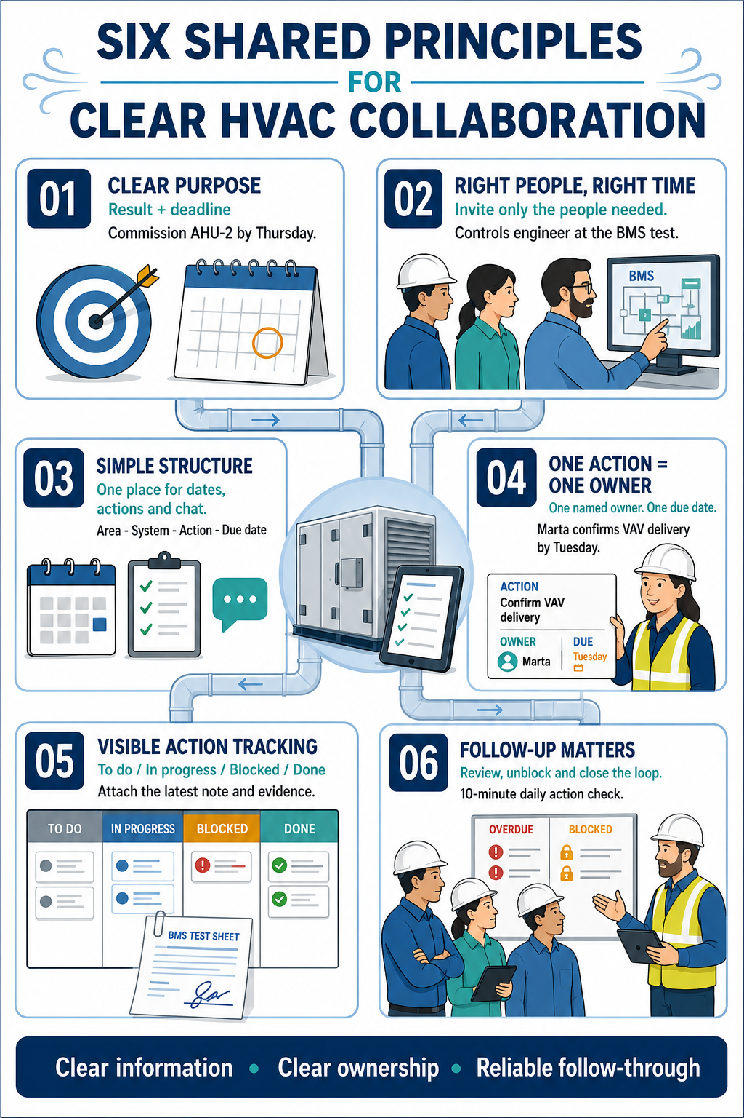

Six shared principles:

01 Clear purpose
Meaning: State the result the team needs, not just the activity.
HVAC example: “Commission AHU-2 by Thursday so the Level 3 ceiling can close on Friday.”
Simple tool cue: Put the outcome and deadline in the calendar event or task title.

02 Right people, right time
Meaning: Include the people who can decide, provide information or complete the work - when their input is needed.
HVAC example: Invite the controls engineer to the BMS point-to-point test, not every general progress meeting.
Simple tool cue: Use focused calendar invites and small messaging groups for each workstream.

03 Simple structure
Meaning: Agree one easy place for dates, one for actions and one for quick discussion.
HVAC example: The shared calendar holds shutdowns and inspections; the task list holds actions; the project chat handles short coordination questions.
Simple tool cue: Keep naming consistent: Area - System - Action - Due date.

04 One action = one owner
Meaning: Give each action to one named person. Others may support, but ownership is never shared or unclear.
HVAC example: “Marta - confirm the VAV controller delivery date by 15:00 Tuesday.” The supplier and site manager can be followers, but Marta owns the update.
Simple tool cue: Every task must have one owner and one due date.

05 Visible action tracking
Meaning: Record actions where the team can see the current status, latest note and evidence of completion.
HVAC example: The condensate drain test moves from To do to In progress to Done, with the signed test sheet attached.
Simple tool cue: Use a short status set: To do / In progress / Blocked / Done.

06 Follow-up matters
Meaning: Review open actions, unblock delays and close the loop. A recorded task is useful only when someone checks it.
HVAC example: At the daily 10-minute coordination check, the supervisor reviews overdue and blocked items before discussing new work.
Simple tool cue: Set a recurring review and notify owners before deadlines.

What a good action record looks like
Action | Owner | Due | Status | Latest update / evidence
Confirm AHU-2 power available for commissioning | Elena | Thu 14:00 | In progress | DB energisation booked; photo to be added after test
Before ending any meeting, ask: What is the action? Who owns it? When is it due? Where will we track it?

2. Scenario / case study – recognition and consequence

Scenario. Using collaboration techniques to keep an HVAC project on track

An HVAC company is installing a new heating and ventilation system in a medium-sized office building. The project requires close coordination between the project managers, on-site technicians, electrical subcontractor, and equipment supplier.
During the early stages, several coordination problems emerge:
- Project drawings are interpreted differently by team members.
- Equipment deliveries are late or missed.
- Technicians are unsure who to contact when issues arise.
- Poor sequencing causes delays between HVAC and electrical work.
The project manager recognises that ineffective coordination is increasing costs, reducing productivity, and putting the programme at risk. To bring the project back on track, the team introduces three practical collaboration techniques.
1. Start-up workshop
Before work continues, the project team holds a start-up workshop to:
- Review the drawings and agree on the installation sequence.
- Define responsibilities and confirm key points of contact.
- Verify delivery dates and important project milestones.
- Assign every action to one named owner with a clear deadline.
The workshop establishes a shared understanding of the work, responsibilities, and programme.
2. Weekly check-ins
The project manager, site supervisor, subcontractor, and supplier hold a short weekly meeting to:
- Review completed, outstanding, and overdue actions.
- Confirm upcoming activities and equipment deliveries.
- Identify risks, delays, and blocked work.
- Agree on new actions, owners, and deadlines.
For example, when the supplier reports a delay to a ductwork delivery, the team adjusts the installation sequence and completes other planned work. This prevents the loss of two working days.
3. Daily stand-ups
The site team holds a ten-minute meeting each morning to confirm:
- What was completed the previous day.
- What must be completed that day.
- Any issues blocking progress.
- What support, information, or materials are required.
During one stand-up, the team discovers that electrical containment is obstructing an equipment lifting route. The electrical subcontractor relocates it before the delivery arrives, avoiding disruption and delay.
Consequences
These collaboration techniques lead to:
- Faster resolution of drawing queries.
- Improved coordination of deliveries and site activities.
- Clear ownership of actions and decisions.
- Fewer installation errors and programme delays.
- Less time spent searching for information or chasing updates.
These benefits depend on consistent follow-through. If actions are not recorded, assigned, updated, and reviewed, coordination problems can quickly return.
Key lesson: Simple meetings and digital tools are effective only when every action has a clear owner, deadline, and confirmed outcome.

Case study. Using shared documentation to improve coordination on an HVAC project
Project overview
An HVAC company was appointed to install and commission new systems in a refurbished healthcare facility.
The project involves:
- Multiple HVAC technicians working across different zones
- A project manager and office administrator
- External contractors (electrical and controls)
- Strict documentation requirements for compliance and handover
At the start of the project, documentation is stored in different places:
- Drawings are emailed as attachments
- Photos are saved on personal phones
- Commissioning sheets exist in multiple versions
This leads to confusion, rework, and time wasted searching for the correct information.
The challenge
The team identified several documentation issues:
- Technicians could not easily confirm which drawings were current.
- Inconsistent file names such as “final,” “new final,” and “use this one” made documents difficult to identify.
- Commissioning and handover records were incomplete or duplicated.
- Office staff spent valuable time locating files and checking versions.
- Essential site evidence was not always available when required.
These problems increased the risk of installation errors, unsuccessful compliance checks, and delays to final handover.
The solution: shared documentation standards
Figure. Share Documentation on an HVAC Project
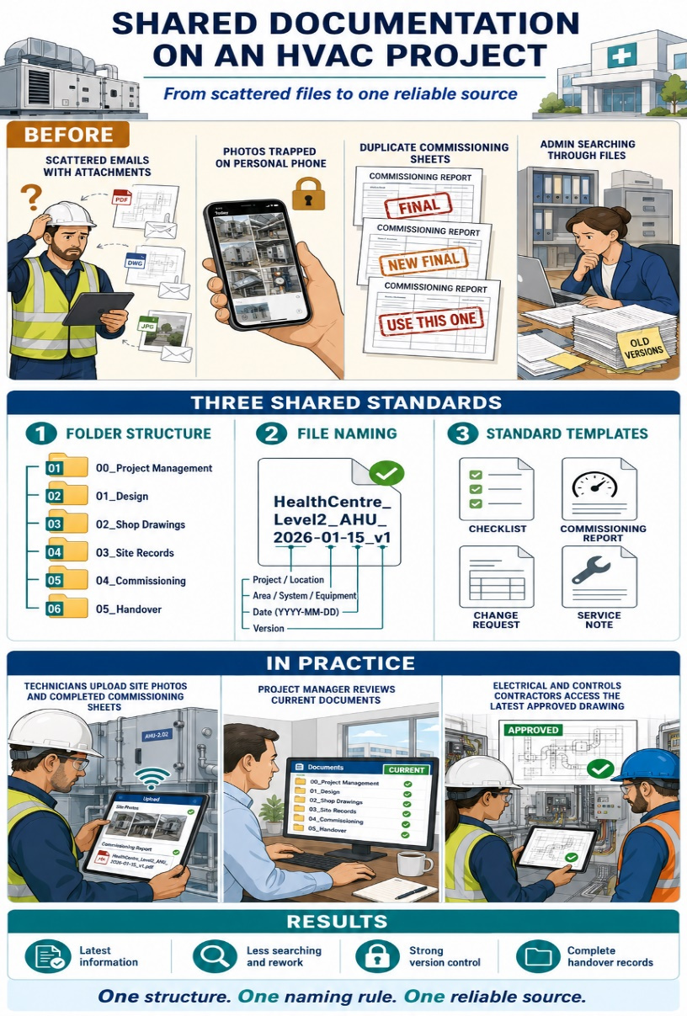

The company introduced a shared cloud-based document system supported by three clear standards.
1. Consistent folder structure
All team members used the same six project folders:
- 01_Project overview
- 02_Drawings and specifications
- 03_Installation photos
- 04_Testing and commissioning
- 05_Change requests
- 06_Handover documents
The numbered structure made information quicker to locate and provided a consistent format that could be reused across future projects.
2. Clear file-naming rules
The team adopted a standard naming convention:
Project – Area/Zone – Document type – Date – Version
For example:
HealthCentre_Level2_AHU_Commissioning_2026-01-15_v1
This allowed users to identify each document’s project, location, purpose, date, and version without opening the file. Superseded documents were archived so that only the current approved version remained in the active folder.
3. Standard templates
The company introduced common templates for:
- Site checklists
- Commissioning reports
- Change requests
- Service and maintenance notes
Each template included the required details relating to the project, location, equipment, inspection, approval, and completion status. This improved consistency and reduced the risk of important information being omitted.
How it worked in practice
Technicians uploaded installation photos, completed checklists, and commissioning records directly from site. The project manager reviewed and updated documents in real time, while the office administrator checked that files were correctly named and stored. Electrical and controls contractors used the same system to access current drawings and submit testing information.
This provided everyone with access to the latest approved information, regardless of their location.
Results
The shared documentation system reduced the time spent searching for files, strengthened version control, and provided the site and office teams with one reliable source of project information. Handover records were compiled throughout the project rather than collected at the end, making the final compliance review faster and more efficient.
Key lesson: Effective document control requires a logical folder structure, consistent file names, standard templates, and shared responsibility.

3. Applied reflection – personal/team relevance
Using Task Boards and Trackers on an HVAC Project
Task boards and trackers help HVAC teams organise work, monitor actions, and improve project coordination.
Individual reflection
1. Current practice
Consider how you currently organise, prioritise, and monitor your work.
- How do you record installation tasks, inspections, defects, and commissioning actions?
- Do you rely on memory, handwritten notes, emails, messages, or spreadsheets?
- How do you decide which task should be completed next?
- How do you monitor approaching deadlines and follow-up actions?
HVAC example: A technician may use a handwritten list to record VAV units awaiting testing. A digital task board could show which units are To do, In progress, Blocked, or Done.
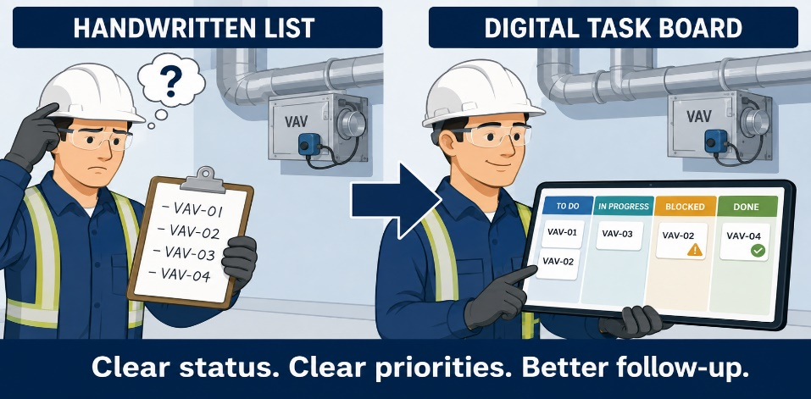
2. Personal benefit
Consider how a simple tracker could help you work more effectively.
- Could it help you prioritise urgent or overdue tasks?
- Would it reduce the need to remember several actions at once?
- Could it provide a clearer record of completed work and progress?
- Would it help you identify missing information, materials, or approvals earlier?
HVAC example: A technician marks an AHU commissioning task as Blocked and records that permanent electrical power is required. The cause of the delay is immediately visible, reducing the need for repeated calls or messages.
3. Ease of use
Consider what would make the tool practical during a normal working day.
- Can tasks be created and updated quickly from a phone or tablet?
- Are the task description, owner, deadline, and status clear?
- Does the system include unnecessary fields or complicated steps?
- What guidance or training would support consistent use?
A task board must be quick and simple to update on site. If the process is time-consuming or unclear, team members are less likely to keep the information current.
Team reflection
1. Team coordination
Consider how a shared task board could improve coordination between project managers, technicians, suppliers, and subcontractors.
- Can everyone see who is responsible for each action?
- Are dependencies between HVAC, electrical, controls, and building work clearly identified?
- Can blocked activities be recognised and resolved before they affect the programme?
- Can the board support daily stand-ups and weekly progress reviews?
HVAC example: The board shows that ductwork installation cannot begin until the ceiling supports have been approved. The project manager assigns the approval action to one person and monitors the agreed deadline.
2. Shared visibility
Consider whether all team members can access the same current information.
- Can the office and site teams view the latest task status?
- Are overdue and blocked actions immediately visible?
- Can drawings, photographs, test sheets, and progress notes be attached to tasks?
- Does the tracker reduce the time spent requesting or chasing updates?
HVAC example: A pressure test is marked as Done, and the signed test sheet is attached to the task. The project manager and commissioning team can review the evidence without asking the technician to resend it.
3. Consistency
Consider how the team could use the board in a consistent and reliable way.
- Does every task have one named owner and a clear deadline?
- Does everyone use the same status categories?
- Are tasks named using an agreed format?
- When and how often should the board be reviewed?
A simple task standard could include:
- Task name: Area – System – Action
- Owner: One named person
- Due date: Agreed date and time
- Status: To do / In progress / Blocked / Done
- Evidence: Latest update, photograph, checklist, or test sheet
Personal action
Identify one practical way you could use a task board or tracker on your next HVAC project.
I will use a task board to: __________________________________________
This will help me or my team by: ____________________________________
My first action will be: ____________________________________________

4. Compare-and-contrast – sharpen judgement

Communication Channels and Good Practice in HVAC Projects
Effective HVAC collaboration depends on communicating the right information to the right people, using the most appropriate channel.

Each communication channel has a specific purpose, benefit, and risk.

Table. HVA Communication Channels
Channel | Best used for | Main risk
Face-to-face or phone | Urgent issues, safety concerns, complex discussions, and immediate clarification | Important decisions may not be recorded
Messaging apps | Quick updates, short questions, delivery alerts, and day-to-day coordination | Information can become buried or overlooked
Digital project tools | Actions, deadlines, changes, approvals, progress updates, and supporting evidence | Information becomes unreliable if it is not updated consistently

A Good Communication Process:
- Discuss the issue using the most appropriate channel.
- Agree on the action required.
- Record the action, owner, and deadline.
- Follow up until the action is completed and closed.

HVAC example: A technician identifies a clash between ductwork and electrical containment. The technician raises the issue directly with the electrical supervisor, then records the agreed action, named owner, deadline, and supporting photograph in the project tracker.

Comparing Information-Sharing Approaches
Limited or informal sharing
Information is exchanged through private conversations, calls, or individual messages.
Likely result: Key people may be missed, responsibilities remain unclear, and delays become more likely.

Shared but unstructured communication
Information is available across emails, chats, and folders, but there are no agreed rules for storing or updating it.
Likely result: Updates are difficult to locate, actions may be overlooked, and teams risk working from outdated information.

Structured and transparent communication
The team uses agreed communication channels, shared file locations, standard task statuses, named owners, and clear deadlines.
Likely result: Current information is visible, responsibilities are clear, and risks can be identified and resolved earlier.

Professional Judgement Check
Before choosing a communication channel, consider:
- How urgent is the issue?
- Who needs to know, decide, or act?
- Could the information be misunderstood?
- Is a formal or traceable record required?
- Does the action need a named owner and deadline?

Key lesson: Use conversations and messages for speed and immediate coordination, but record important decisions, responsibilities, and actions in the shared project system.

